
MEMORANDUM
10/19/2025
TO: | Charlie Refvem, Mechanical Engineering Department, Cal Poly SLO  crefvem@calpoly.edu
FROM: | Tarsem Pal  shpal@calpoly.edu
GROUP: | N/A
SUBJECT: | Homework 0x03 - System Modeling

Introduction
The purpose of this memo is to present a nonlinear state-space model for our Romi robot. The model is designed to describe Romi’s planar motion and motor behavior to enable future simulation and control system development. This memo includes the derivation of kinematic relationships, incorporation of motor dynamics, and creation of a complete state-space model.
System Description
Romi consists of two independently driven wheels separated by a fixed track width ω, as seen in Figure 1 below:
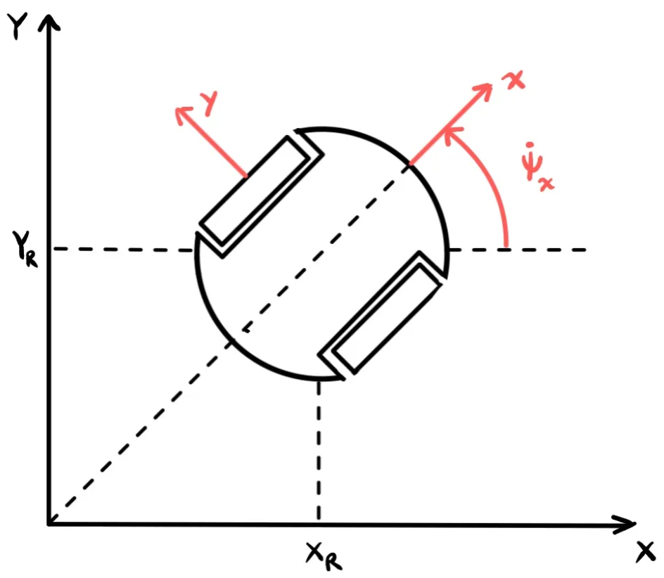
Figure 1: Top Down View of Romi
The robot moves in a 2D plane, with its position described by ($X_{R}, Y_{R}, Ψ_{R}$) representing the x-position, y-position, and orientation.
Modeling Assumptions
For our state space formulation, we made the following assumptions:
- The robot operates on a flat plane.
- Wheels roll without slipping (pure rolling condition).
- Each motor behaves as a first-order system.
- Effects of friction, inertia, and wheel deformation are neglected.
Kinematic Model Derivation
Figure 2 shows the rotational motion of a single wheel, illustrating how wheel angular velocity $Ω_{R}$ and wheel radius r determine the tangential velocity at the contact point.
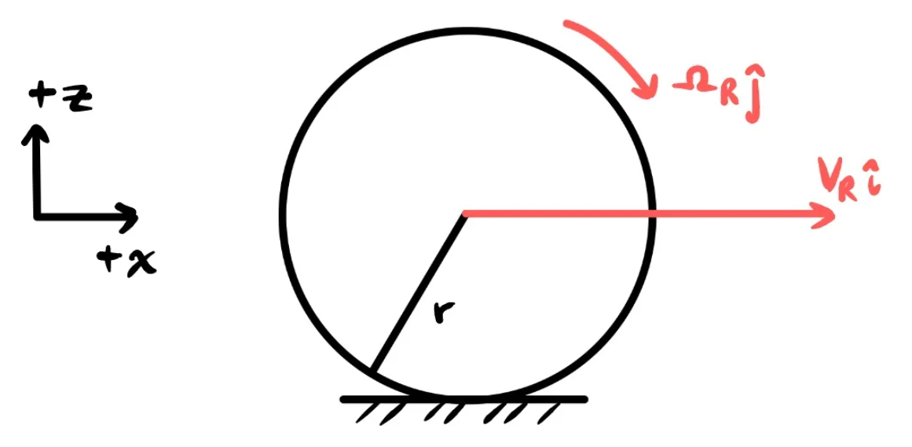
Figure 2: Single wheel schematic showing rotation and linear velocity.
The no-slip condition implies that the velocity at the point of contact with the ground is zero, which means that:
$$v_{R}=rΩ_{R} \text{and} v_{L}=rΩ_{L}$$
Considering both wheels and the geometry of the robot base in the figure below, the left and right wheel velocities contribute to the robot’s forward and rotational motion.

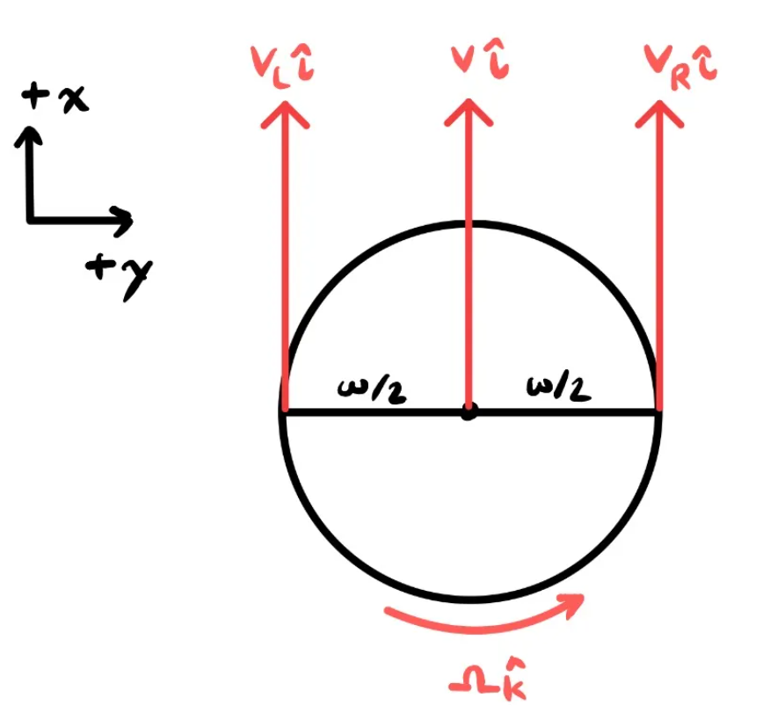
Figure 3: Differential drive geometry showing wheel spacing and velocity vectors.
Let $v_{L}$ and $v_{R}$represent the linear velocities of the left and right wheels. The forward velocity $v$ and angular velocity ${\dot{Ψ}}_{R}$ of the robot are given by:
$$v=\frac{r}{2}\left(Ω_{R}+Ω_{L}\right)$$
$${\dot{Ψ}}_{R}=\frac{r}{ω}\left(Ω_{R}+Ω_{L}\right)$$
where $Ω_{R}$ and $Ω_{L}$ are the right and left angular velocities, respectively. These relationships link wheel rotation to robot translation and turning rate.

To express the robot’s motion in the global frame, we rotate the body-frame velocity components using the robot’s orientation $Ψ_{R}$:
$${\dot{X}}_{R}=vcos⁡(Ψ_{R})$$
$${\dot{Y}}_{R}=vsin⁡(Ψ_{R})$$
Together, these form the nonlinear kinematic equations for planar motion:
$$\begin{matrix}{\dot{X}}_{R} & =\frac{r}{2}(Ω_{R}+Ω_{L})cos⁡(Ψ_{R}) \\ {\dot{Y}}_{R} & =\frac{r}{2}(Ω_{R}+Ω_{L})sin⁡(Ψ_{R}) \\ {\dot{Ψ}}_{R} & =\frac{r}{ω}(Ω_{R}-Ω_{L})\end{matrix}$$
…
Conclusion

Matrix

$$\dot{x}=Ax+Bu$$
$$\dot{x}=\left[\begin{matrix}0 & 0 & 0 & 0 & -\frac{r}{2}\cos{Ψ_{R}} & \frac{r}{2}\cos{Ψ_{R}} \\ 0 & 0 & 0 & 0 & \frac{r}{2}\sin{Ψ_{R}} & \frac{r}{2}\sin{Ψ_{R}} \\ 0 & 0 & 0 & 0 & -\frac{r}{ω} & \frac{r}{ω} \\ 0 & 0 & 0 & 0 & \frac{r}{2} & \frac{r}{2} \\ 0 & 0 & 0 & 0 & -\frac{1}{τ} & 0 \\ 0 & 0 & 0 & 0 & 0 & \frac{1}{τ}\end{matrix}\right]\left[\begin{matrix}X_{R} \\ Y_{R} \\ Ψ_{R} \\ s \\ v \\ Ω\end{matrix}\right]+\left[\begin{matrix}\frac{k}{τ} & \frac{k}{τ}\end{matrix}\right]\left[\begin{matrix}u_{L} \\ u_{R}\end{matrix}\right]$$

